1st Assignment

Karma is the universal law of cause and effect,where one actions determine future consiquinces.

Good deeds leads to positive outcommes,while bad actions result in suffering.

This principle is deeply embeddrd in Hindu philosophy and linked to dharma and moksha.

'''

Karma_Definition="Karma is universal law of cause and effect"

good_deeds="positive actions leads to good outcomes"

bad_deeds="Negative actions result in suffering"

philosophy="karma is centarl to hindu philosophy"

dharma="karma is linked to dhrma"

moksha="karma influences the path to moksha"

instant_karma="some beleive taht karma has immediate conciquences"

pastlife="past life karma effects the present life"

balance="maintaing the balance of karma is important"

free_will="karma operates alongside free wil and choices"

print(Karma_Definition)

print(good_deeds)

print(bad_deeds)

print(philosophy)

print(dharma)

print(moksha)

print(instant_karma)

print(pastlife)

print(balance)

print(free_will)

output:2nd Assignement

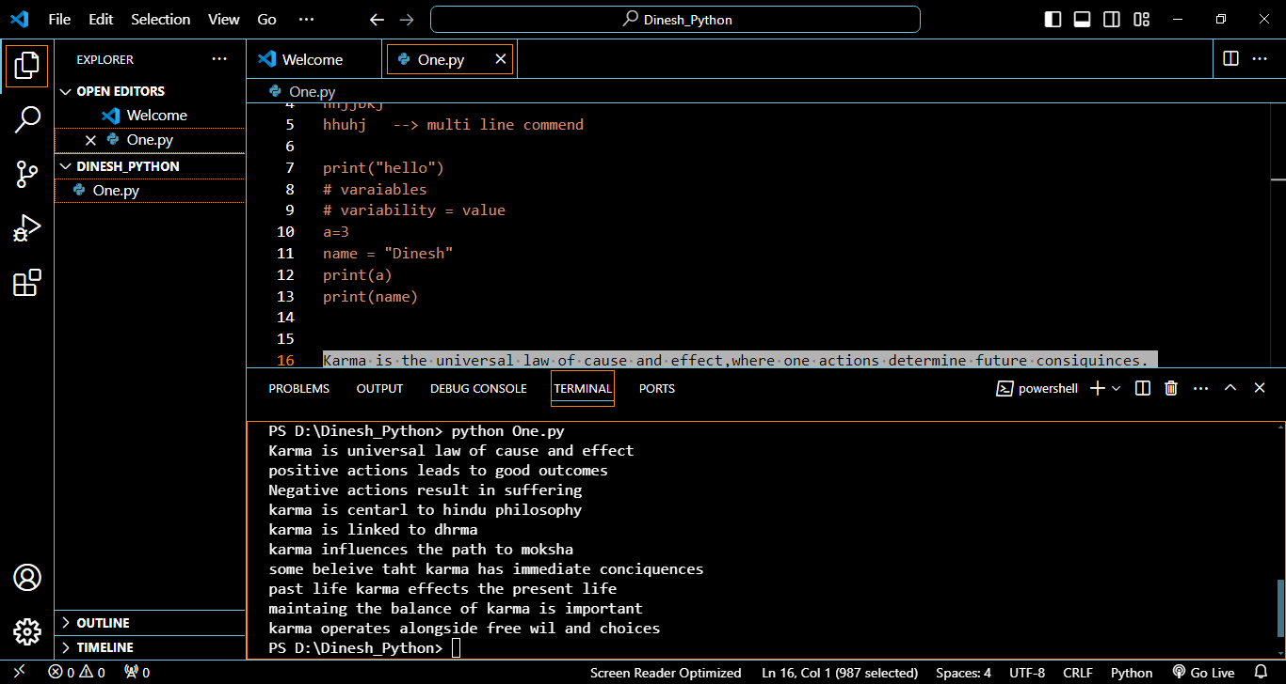

Karma is the universal law of cause and effect,where one actions determine future consiquinces.

Good deeds leads to positive outcommes,while bad actions result in suffering.

This principle is deeply embeddrd in Hindu philosophy and linked to dharma and moksha.

'''

Karma_Definition= input("What is meant by karma  \n ")

good_deeds=input("what is good deeds \n")

bad_deeds= input("what are bad deeds \n")

philosophy= input("in which religion this concept is mostly beleived \n ")

dharma= input("what is dharma \n ")

print("")

print(f"{Karma_Definition} and {good_deeds} while {bad_deeds},\n"

         f"this concept is mostly belived in {philosophy}. \n"

         f"and directly connects to concept of dharma while {dharma}.")

output:

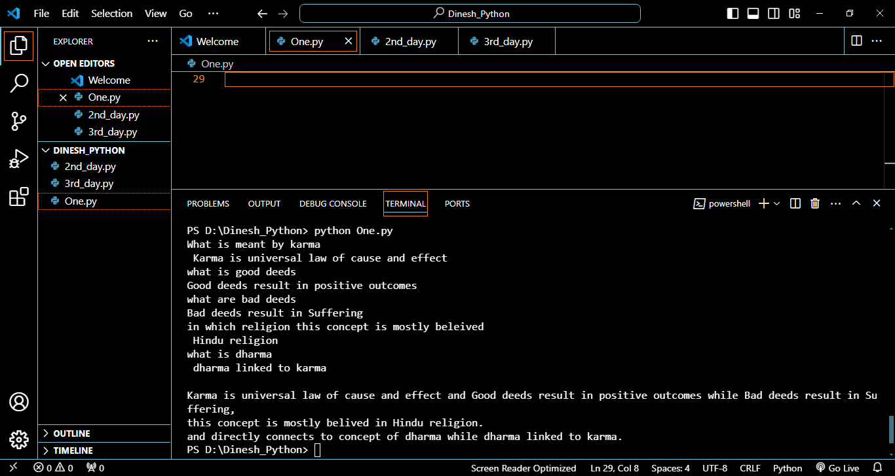

3rd assignement

students=["Rakesh","Ramesh","Suresh","Ram","Rajesh"]

subjects=("Maths","Stats","Computers")

marks={

        "Rakesh":[80,65,78],

        "Ramesh":[65,67,88],

        "Suresh":[75,54,76],

        "Ram":[53,87,67],

        "Rajesh":[88,92,75]

}

unique_marks=set(marks["Rakesh"]+marks["Ramesh"]+marks["Suresh"]+

                    marks["Ram"]+marks["Rajesh"])

print("Student 1:", students[0],"marks:", marks["Rakesh"],

        "Total:", sum(marks["Rakesh"]))

print("Student 2:", students[1],"marks:", marks["Ramesh"],

        "Total:", sum(marks["Ramesh"]))

print("Student 3:", students[2],"marks:", marks["Suresh"],

        "Total:", sum(marks["Suresh"]))

print("Student 4:", students[3],"marks:", marks["Ram"],

        "Total:", sum(marks["Ram"]))

print("Student 5:", students[4],"marks:", marks["Rajesh"],

        "Total:", sum(marks["Rajesh"]))

print("unique marks are ", unique_marks)

output:

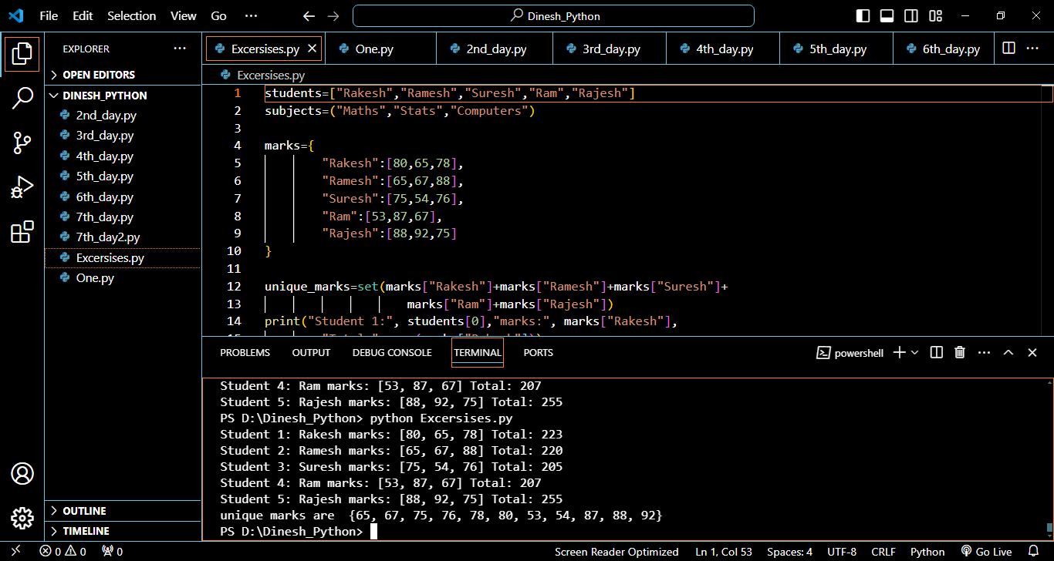

Assignment 4:

launagues=["python","java","c","c++"]

user_data={}

name=input("enter your name: ")

age=int(input("enter your age: "))

fav_lag=input("enter your favorite launguage: ")

experience=input("do you have any experience (yes/no): ")

user_data["Name"]=name

user_data["Age"]=age

user_data["Favourite Launguage"]=fav_lag

user_data["Experience"]=experience

if age<=18:

    category="Teenager"

elif 18<=age<=30:

    category="Young adult"

else:

    category="Adult"

user_data["category"]=category

if fav_lag in launagues:

    print(f"Nice choice, {fav_lag} is very poular launague..")

else:

    print("Thats great choice..!")

if experience.lower()=="yes":

    years=int(input("how many years experience do you have..? "))

    if years < 2:

        print("you are at beginner level..")

    elif 2< years <5:

        print(" you are at intermediate level ")

    else:

        print(" you are expert , wishing a great success")

else:

    print(f"no worries its fine as you are fresher",

            "everyone starts at somewhere,,just start now..")

if user_data["Age"]<25 and user_data["Experience"]=="no":

    print("you are young and have great journey ahed in programming..")

if user_data["Favourite Launguage"]=="java" or \

    user_data["Favourite Launguage"]=="python":

    print("you are choosen a graet launguae")

output:

